MIS-64061: Advanced Machine Learning

Final Project Report

Store Sales – Time Series Forecasting
By:
Balaji Ravi Kumar



Table of contents
S.no | Content | Page. No
1 | Introduction | 3-4
2 | Methodology | 4-5
3 | Implementation | 5-23
4 | Modelling | 23-25
5 | Conclusion | 25
6 | Contribution | 26-27

1.INTRODUCTION
Forecasting: Forecasting isn't just for meteorologists. Governments promote growth in the economy. Scientists make efforts to forecast the future population. Data scientists are also used by organizations to predict future product demand. Traditional grocery stores depend mainly on prediction since they have to carefully balance how much inventory they buy. Overestimating will result in an oversupply of perishable products. If you make a low guess, popular things will rapidly sell out, costing you money and upsetting your customers.
Existing Model: The subjective retail forecasting techniques now in use are based on minimal data and are not likely to be automated. As more regions with specialized demands, new products, ever-evolving seasonal tastes, and unpredictable product advertising are added to the stores, the situation becomes noticeably more complicated.
Proposed Model: The proposed method will provide more accurate prediction in the supermarket industry, which can minimize food waste from overstocking and increase customer happiness. The outcomes of this ongoing competition will someday promise that the next time you go shopping, your local store will have everything you need.
Time Series Forecasting: A time series is a collection of observations that were made over a specified time and are used to forecast or predict a value over time. Forecasting is done to evaluate a company's potential and to minimize losses. In this project, we are forecasting a store sale based on the information from Corporación Favorita, a major Ecuadorian supermarket retailer.
Components of Time Series:
Seasonality: The seasonality component shows a pattern that repeats over time in terms of timing, direction, and magnitude.
Cyclical Component: These trends do not even repeat themselves consistently throughout a certain time frame. A time series of ups and downs, booms and busts is referred to as a cycle. These fluctuations are most frequently seen in business cycles.
Irregular Variation -These are the variations in the time series data that are observable after trend and cyclical variations have been eliminated. These deviations are unpredictable, erratic, and possibly random.
ETS Decomposition - A time series can be subdivided into its various parts using ETS Decomposition. Error, Trend, and Seasonality is the term for ETS.
Time Series Decomposition: A time series is divided into several components using a process called time series decomposition. Each component represents a pattern category, trend, seasonality, and noise that underlies the time series.
Seasonality: Seasonality is a term used to define the time series' periodic signal.
Trend: specifies whether the time series is descending, keeping steady, or steadily increasing.
Noise: describes what is left after the time series' seasonality and trend are removed. In other words, the model is unable to account for the data's variability.
These components are combined into an addictive model, which is linear and consistently changes over time by the same amount. Changes in multiplicative models may grow or shrink over time. This breakdown offers a methodical approach to considering a time series forecasting issue.

2. METHODOLOGY
Data Preparation: Our key aim is to anticipate product sales for Corporacion Favorita, an Ecuadorian grocery chain with hundreds of outlets, using the Kaggle data set.
The data preparation process uses the steps listed below in order.
(i)Import, cleaning, and summary of the initial data
(ii)Analyzing Exploratory Data
(iii)Finding the essential supplemental data sets and correlating the factors.
(iv)If necessary, variable modification and creation
(v)Model Design
(vi)Evaluation and comparison of models
3.IMPLEMENTATION
Language – Python
Scikit- for data training and testing
There are two functions that are used to import the data. Start reading from the data. Rapid reading of CSV files is possible with the table package. The vast training data set is read in using fst from the fst package; while the package does not read in csv files, r objects can be written to fst files and read in much more quickly in the future. The 4.5GB of training data is unusually large. To make sure there is enough space in working memory, exploratory data analysis will be applied to a 10% sample of the training data (10% of items). The remaining data sets are significantly smaller and are all read totally with fread function.
Grocery Datasets
To help with sales forecasting, Favorita has provided a number of data sets. The important facts concerning each data collection are outlined in the table below. The main data set, called Train, has roughly 125 million observations. This is the most fundamental sales data, which includes the date, the store, the item, the quantity sold, and if the item was on sale when it was purchased. The data is available from January 1, 2013, through August 15, 2017.
Oil: We'll use oil prices to anticipate grocery sales because Ecuador's economy is heavily dependent on oil prices, and declining oil prices have been challenging for Ecuador.
holidays – An index of all national and local holidays observed by Corporacion Favorita. March 2, 2012 was the first holiday noted, and December 26, 2017 was the most recent. The transferred variables and type variables are particularly intriguing. A weekend holiday that has been moved to another day is known as a shifted holiday. Thus, a vacation that has been rescheduled isn't a vacation. However, if the classification is "Transfer," a holiday from the weekend has been added to the date. A weekend holiday is typically relocated to a Monday or a Friday.
items – A list of every item sold in the stores (identified by an item number rather than a name), along with information about the item's "family" (grocery, cleaning, bakery, etc.), "class" (unclear), and perishability. We are merely evaluating a portion of the objects in order to save memory.
Stores – a list of stores sorted by cluster, location, and category. It is uncertain what type represents. Although there is no information supplied regarding the criteria used in the clustering, the cluster is a pre-selected grouping of retailers based on their qualities. It's likely that whoever performed the clustering had access to more information than was provided with this data, even though we might attempt to cluster independently or at least identify the factors used in clustering.
transactions – These are totals of how many transactions took place in each store on each day, not individual transactions. The data spans the dates of January 1, 2013, and August 15, 2017.
The date string type was changed to datetime after loading the test and training files. We also extract year, week of year, month, and other datetime properties using the datetime variable.
We observe that neither the train nor the test sets of the dataset contain any missing values.
However, there are a lot of 0 values, which could indicate that the store is still not operational or that we are just lacking in data.
We should plot sales for each store to determine. Findings and Action: Some of the stores don't have sales data until 2014, 2015, or 2017, thus we repair them by eliminating dates for these stores from the data.
The libraries that must be imported include the ones listed below.
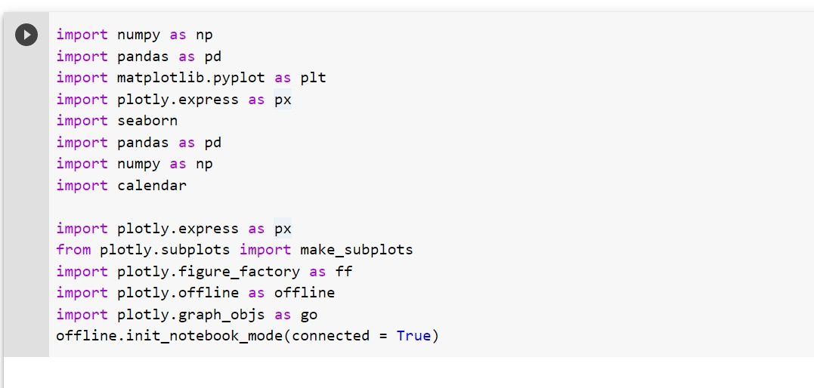
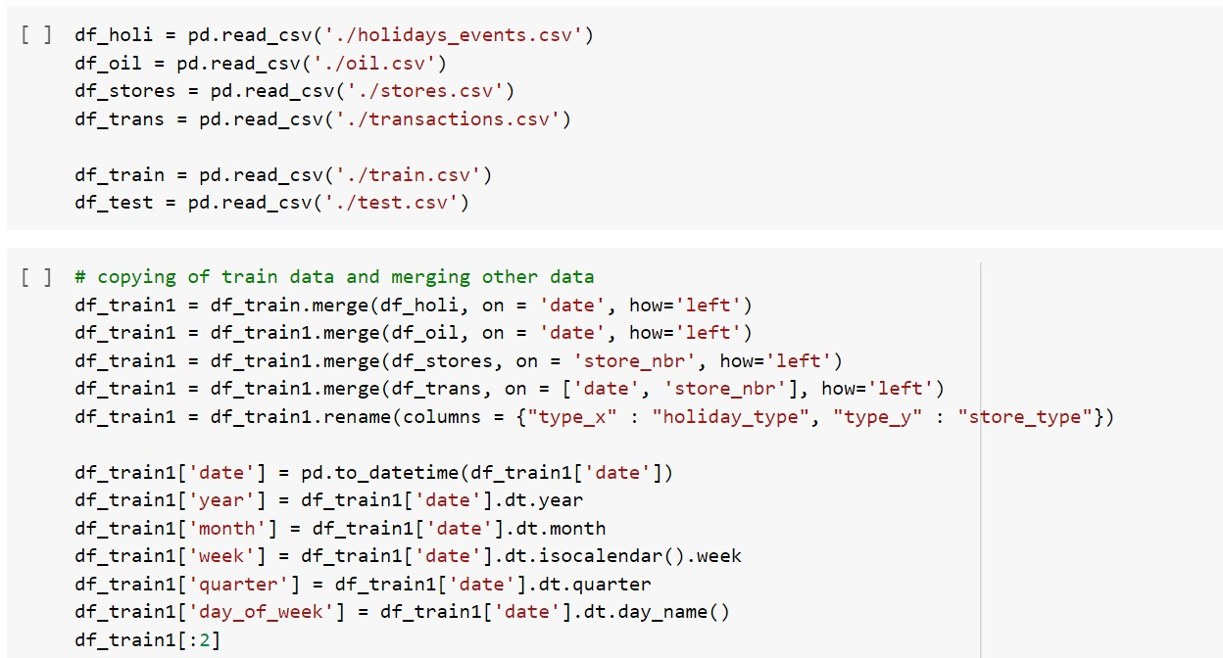
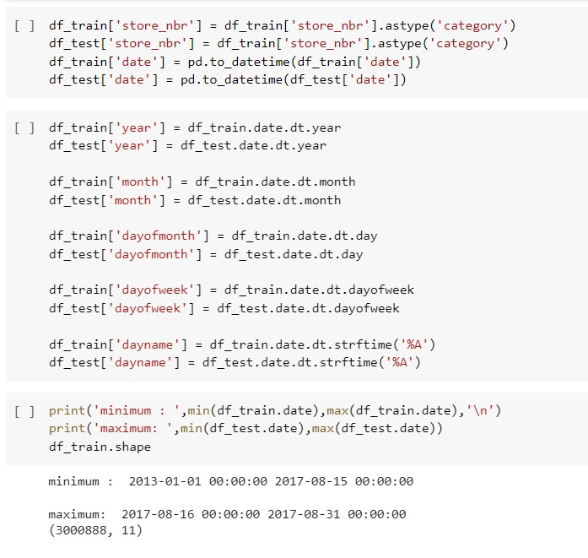
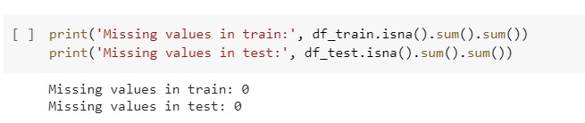
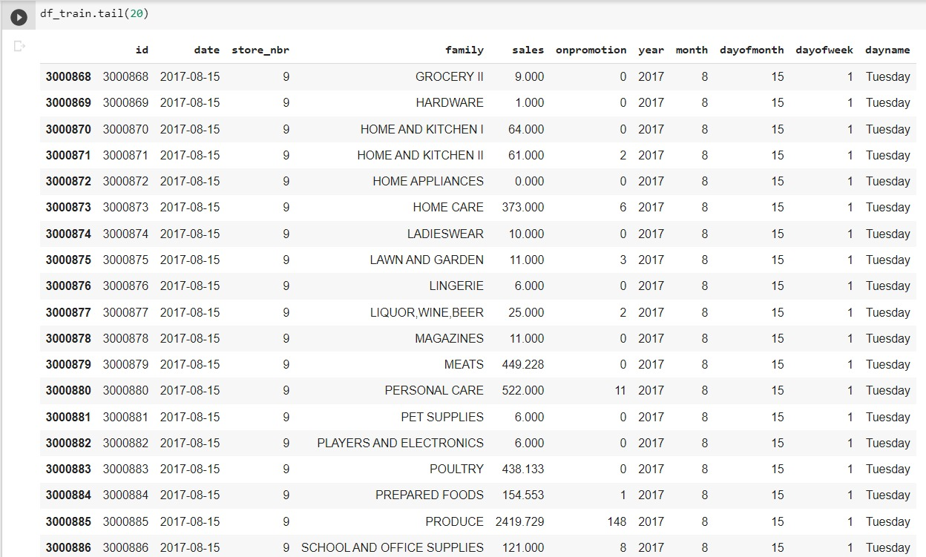
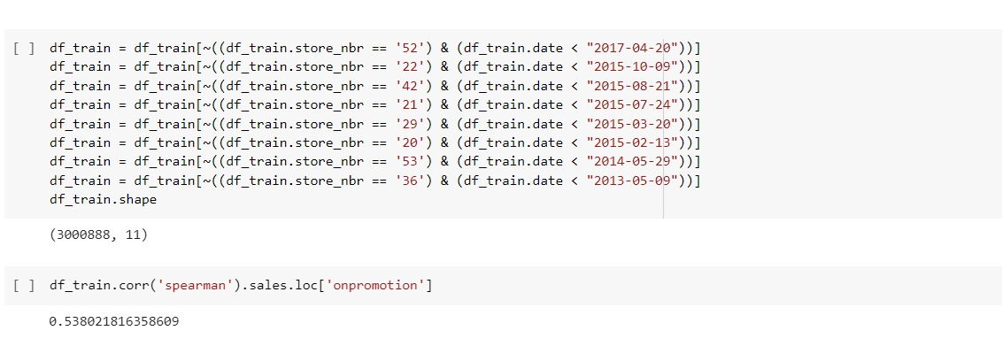
One interesting characteristic that we have in both our train and test datasets is on promotion, which is the total number of products in a product family that were being promoted at a given date.
It seems like it should have a positive impact on sales.
As it turns out, the correlation is just above 0.50, and the scatterplot also displays good findings.
Next, we determine the busiest days, and as predicted, users prefer to shop on Sunday and Saturday (weekends).
The same pattern is evident in transactions, which are higher on weekends. Consequently, one of our reliable forecasts moving ahead can be the weekend.

Total sales from 2013 to 2017 for each store
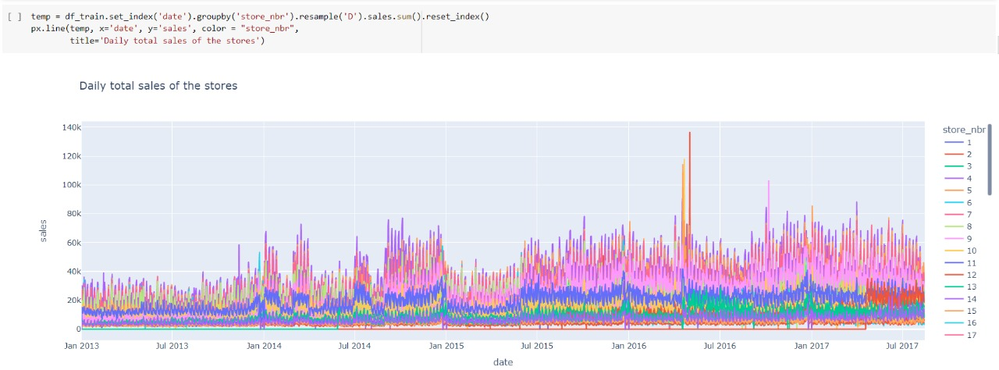
Equador’s economy depends on oil.
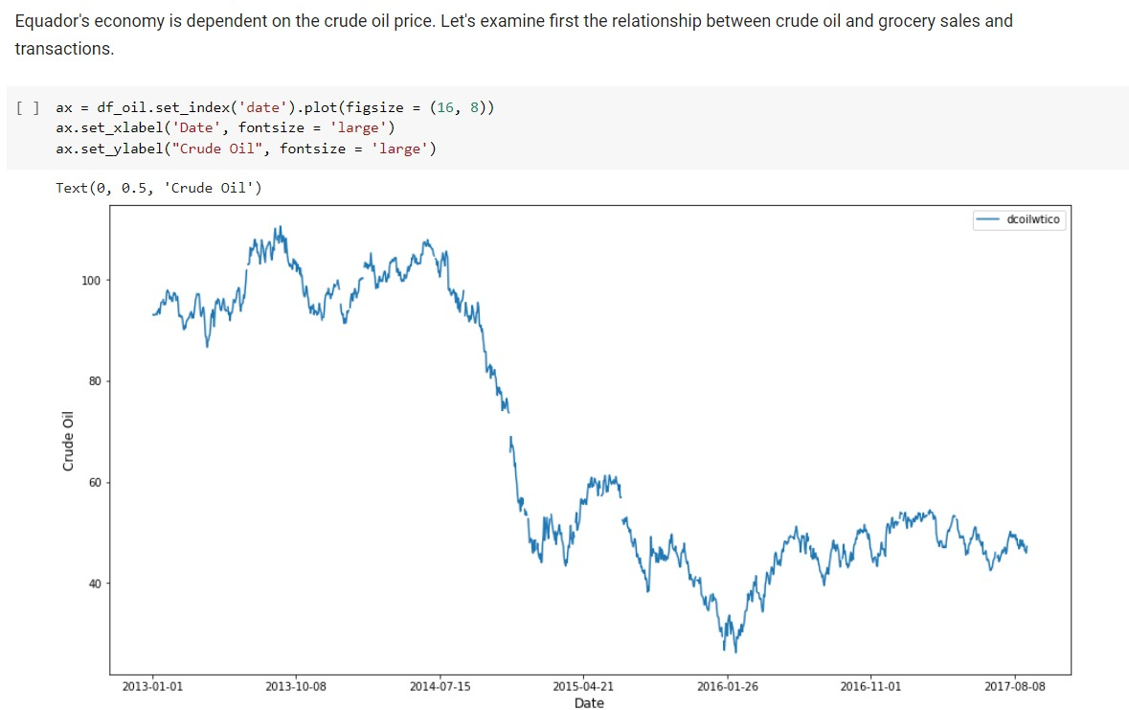
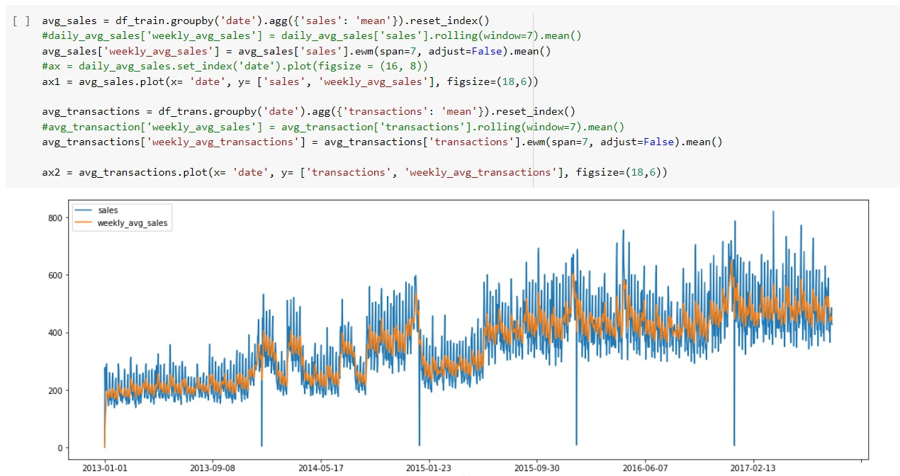
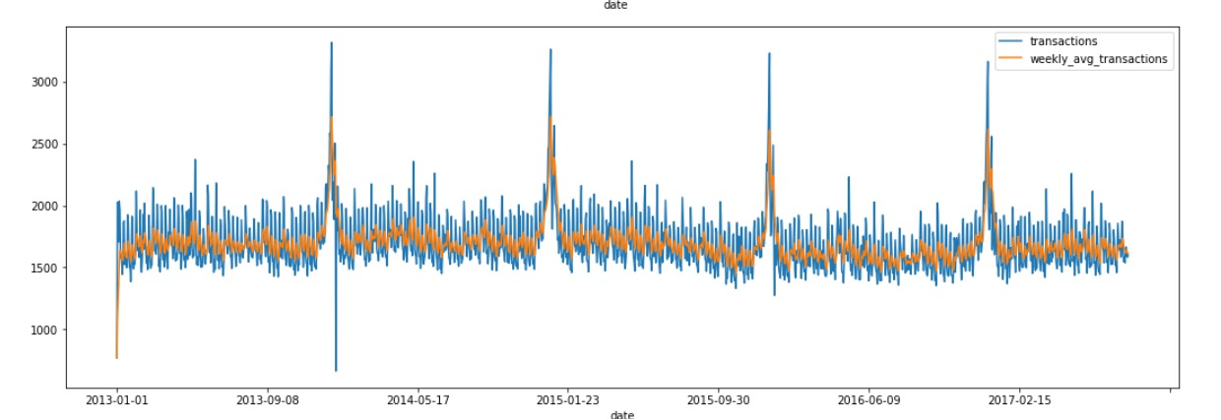
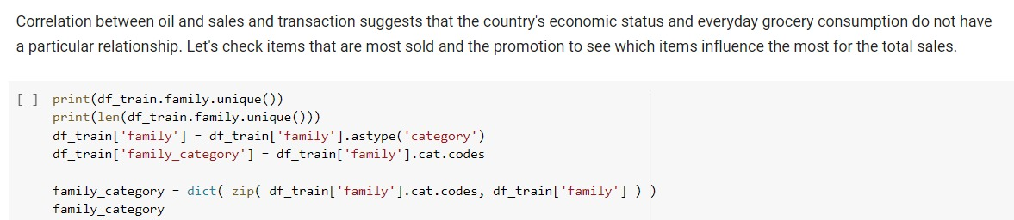
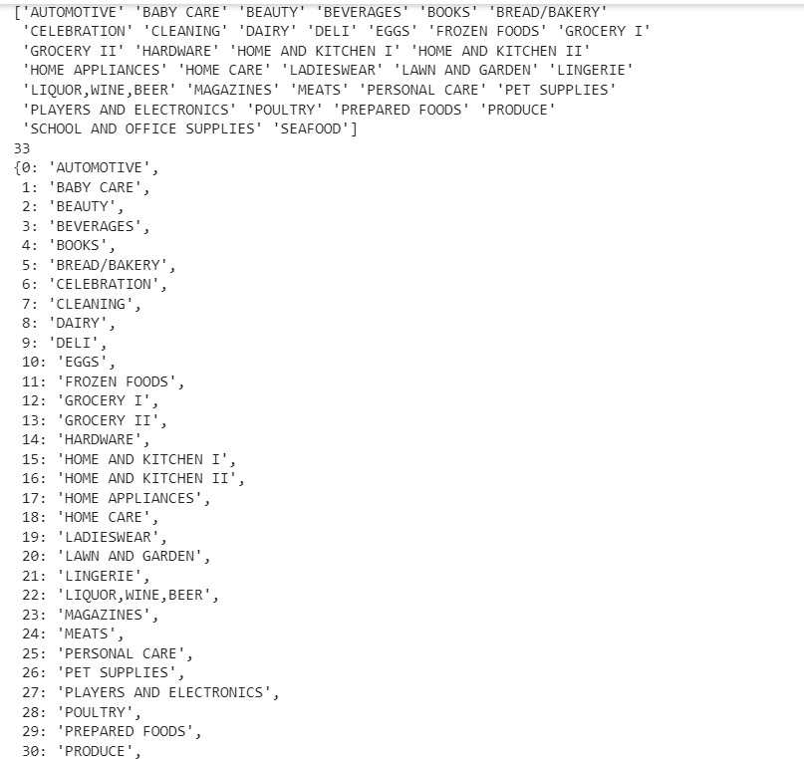
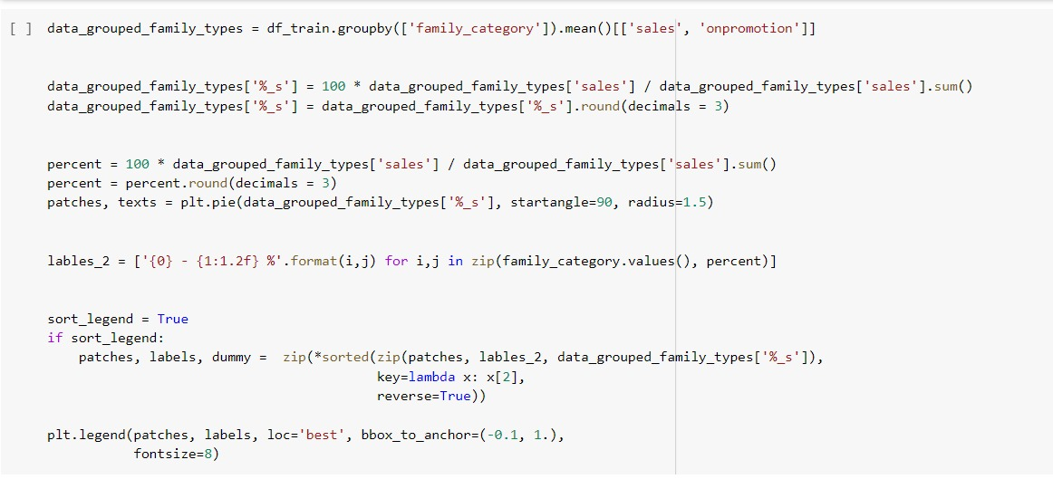
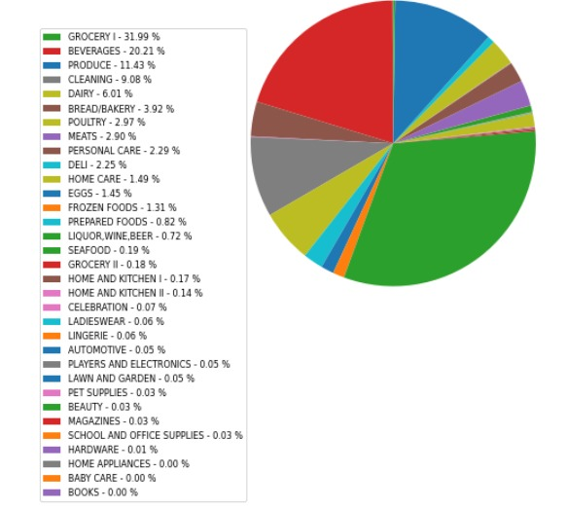
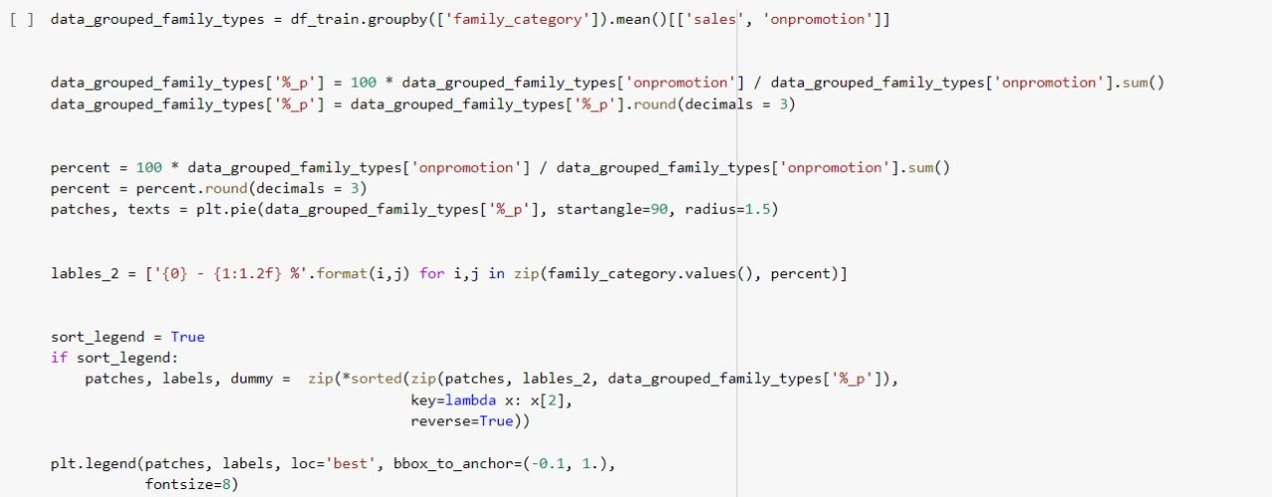
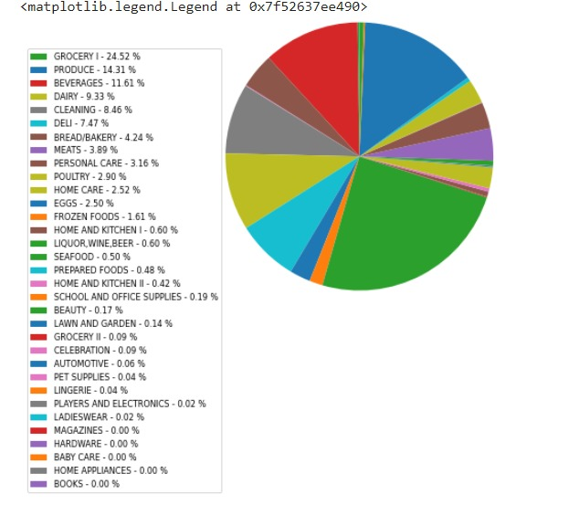
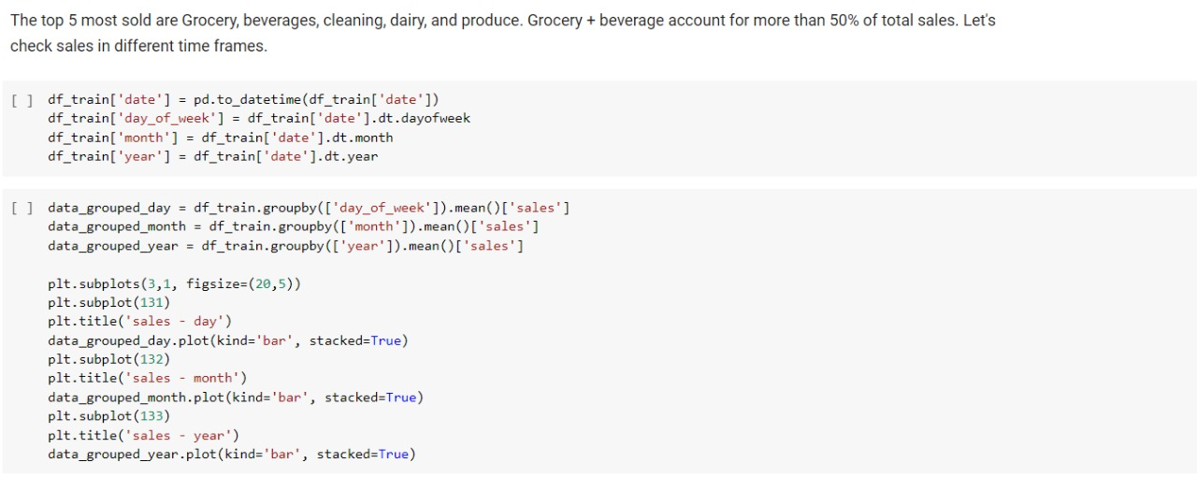
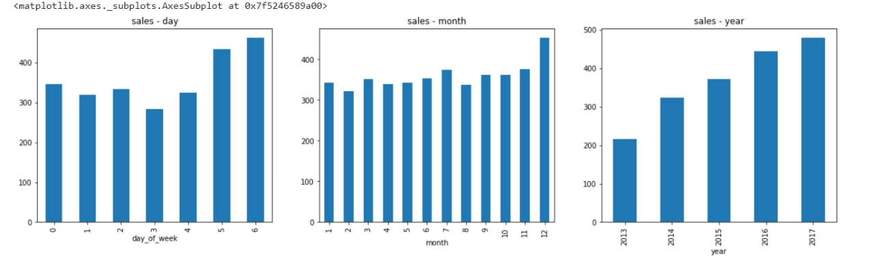
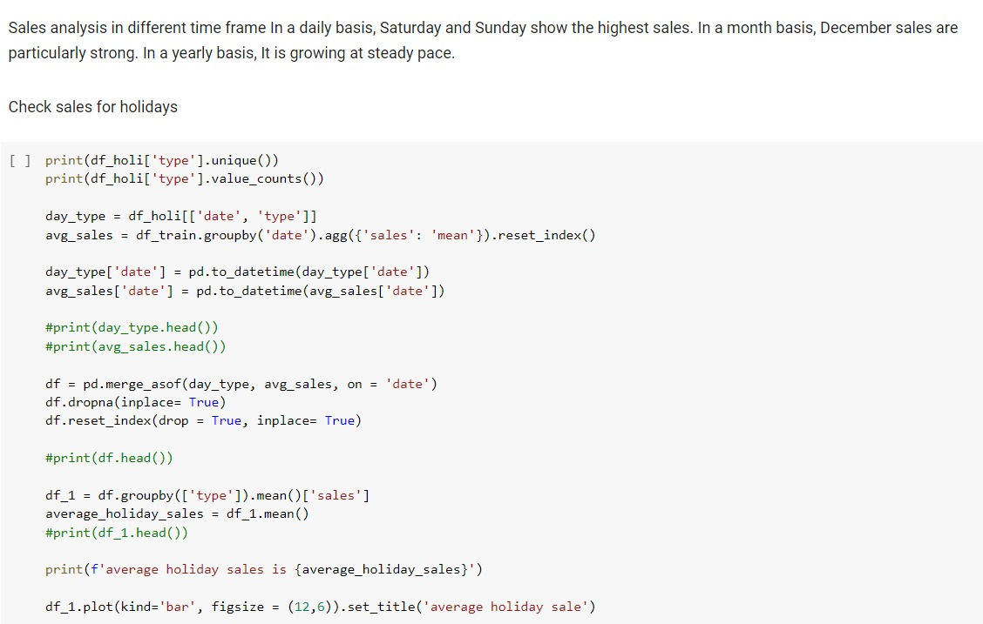
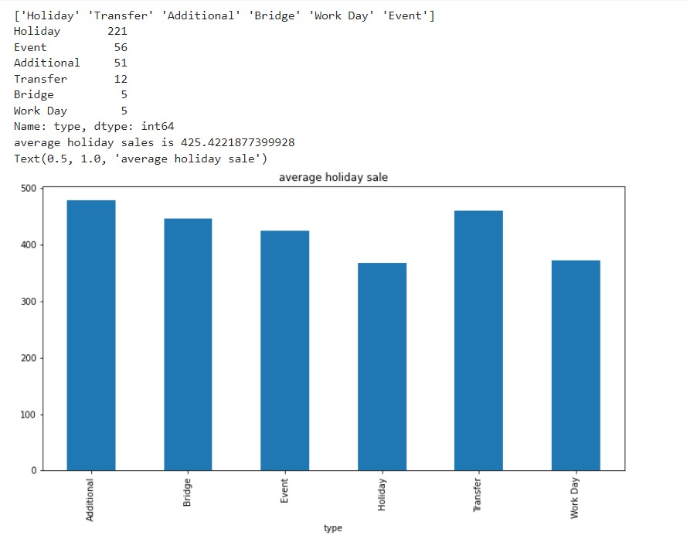
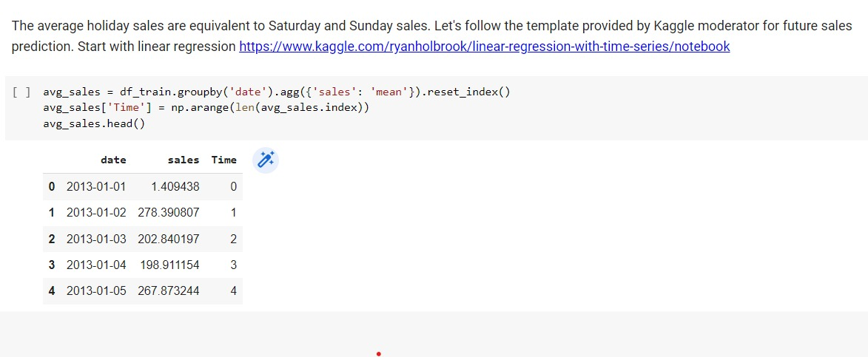
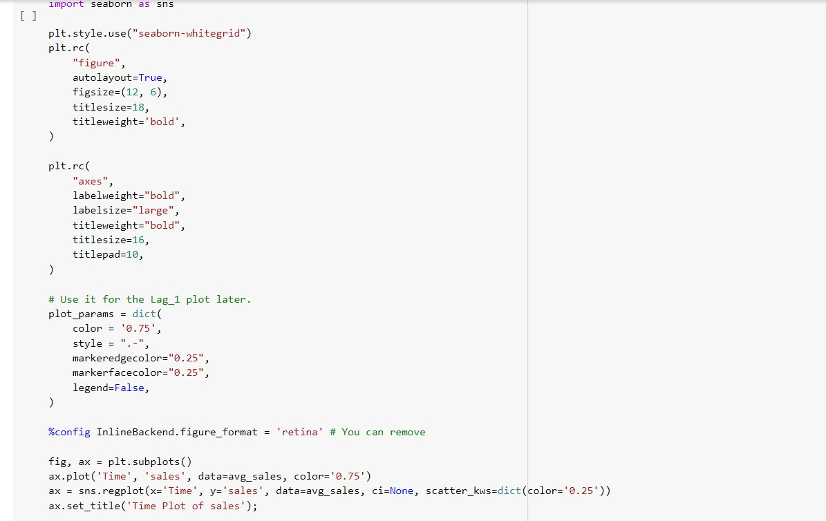
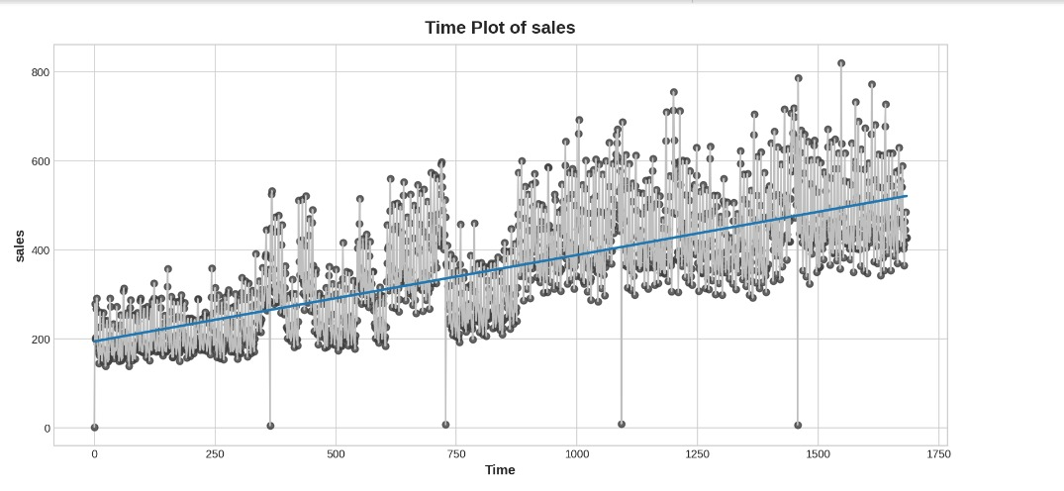
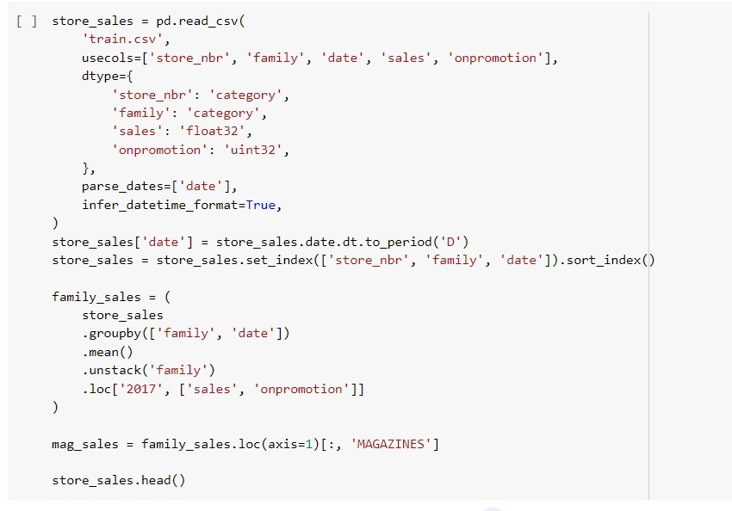
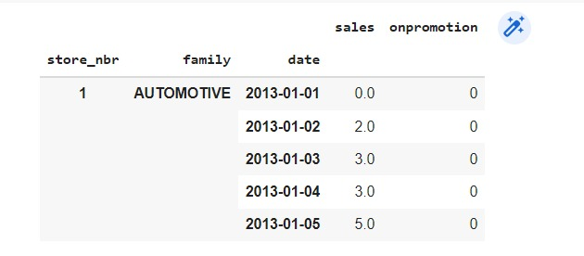
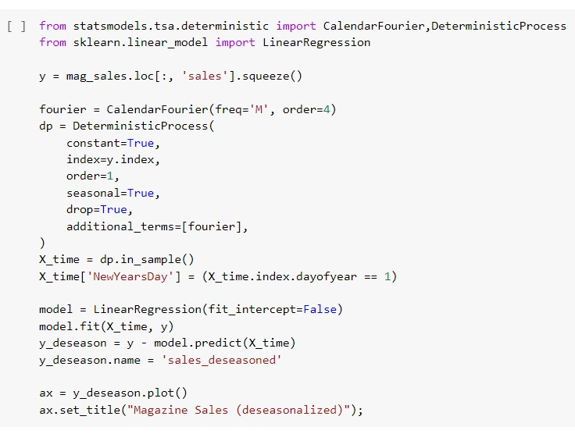
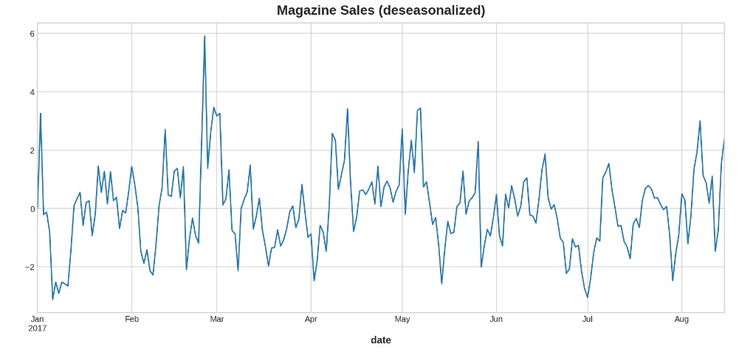
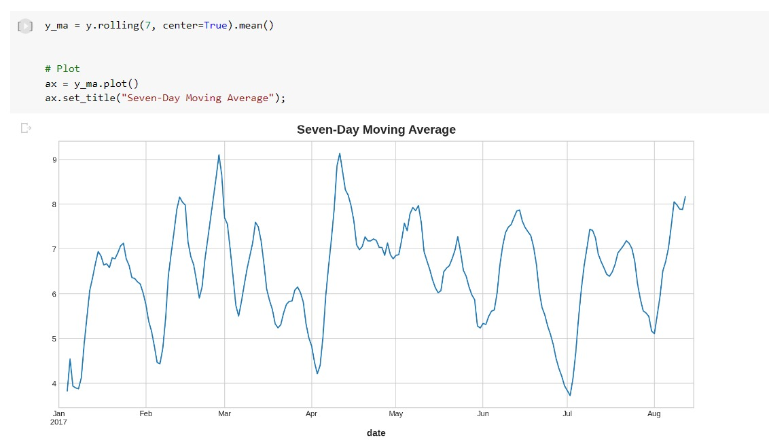
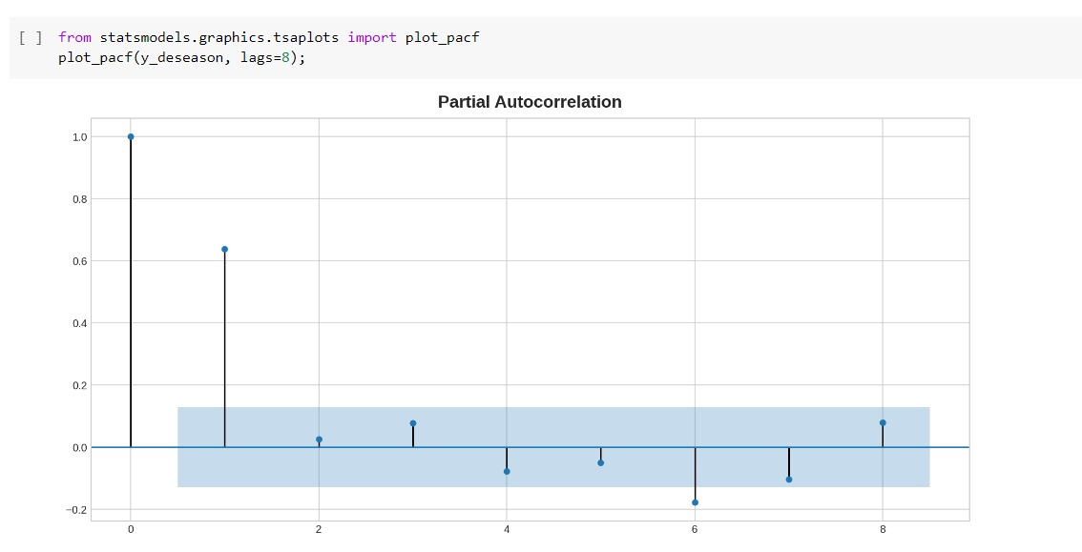

Results of Oil Dataset
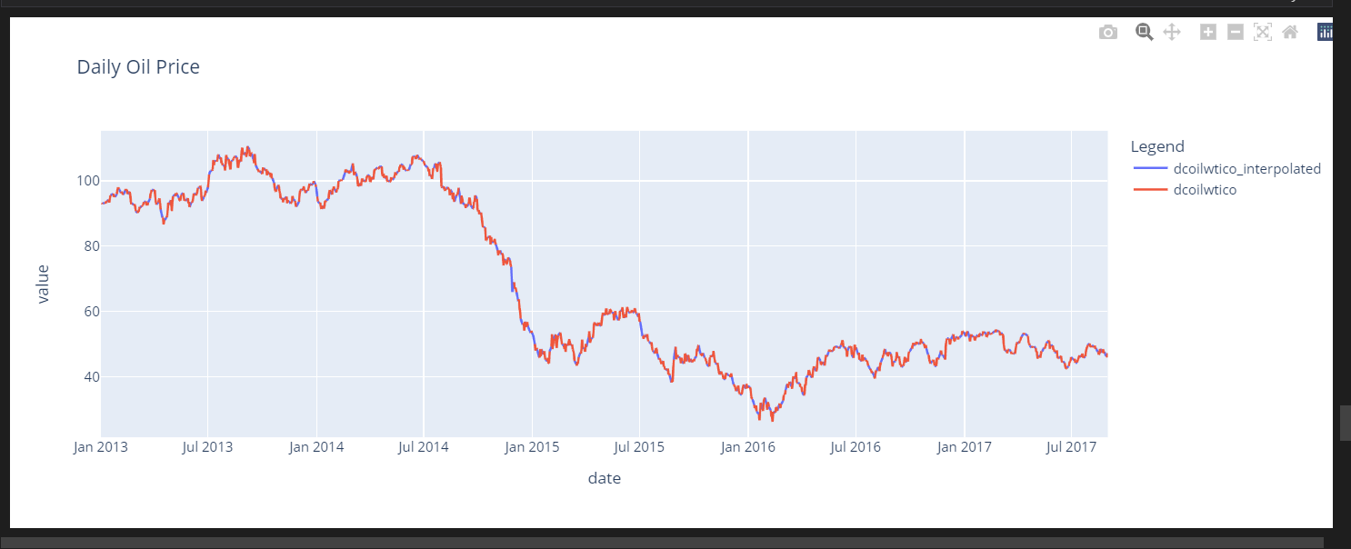

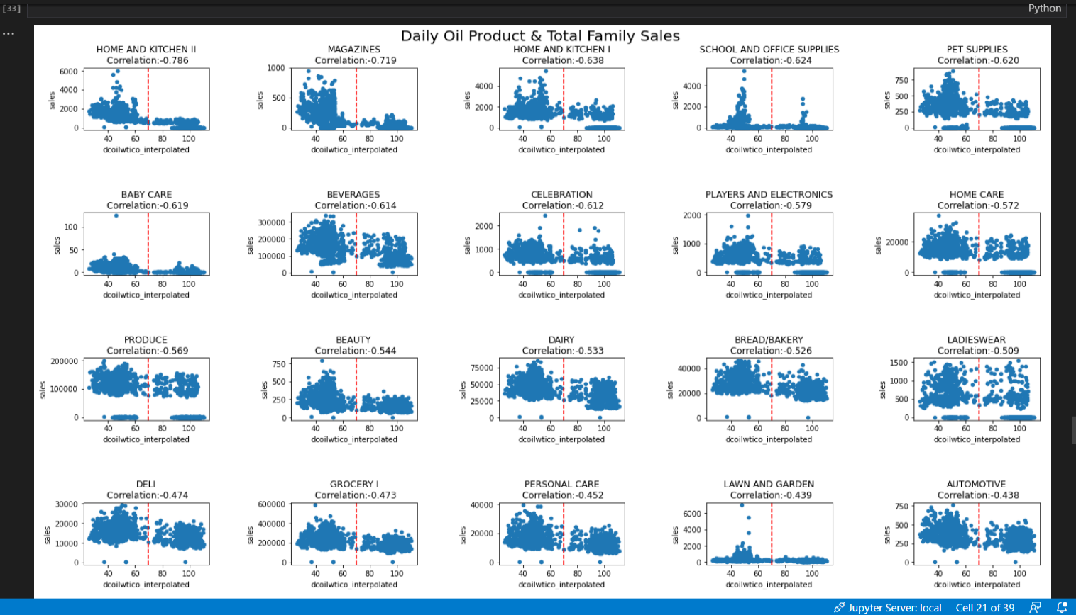
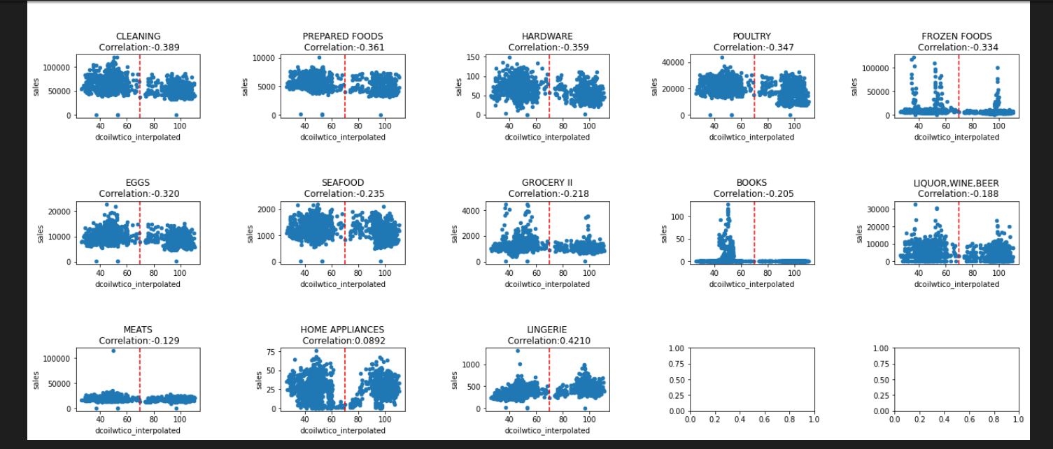

4.MODELLING

Simple linear regression and the XGboost regressor were used in the modeling process.
Modeling the relationship between two continuous variables using simple linear regression. Predicting the value of an output variable (or response) from the value of an input variable (or predictor variable) is frequently the goal.
logarithmic error (MSLE)
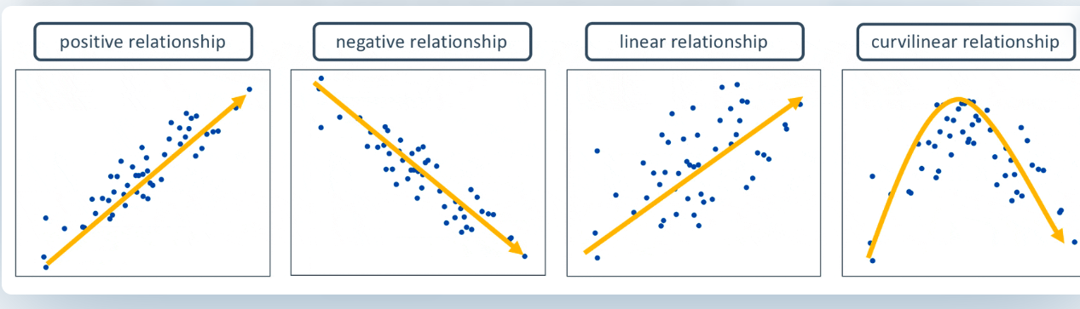

MSLE:
The ratio between the true and expected values can be measured via the mean squared logarithmic error (MSLE).
As the name implies, the mean squared logarithmic error is a variant of the mean squared error.
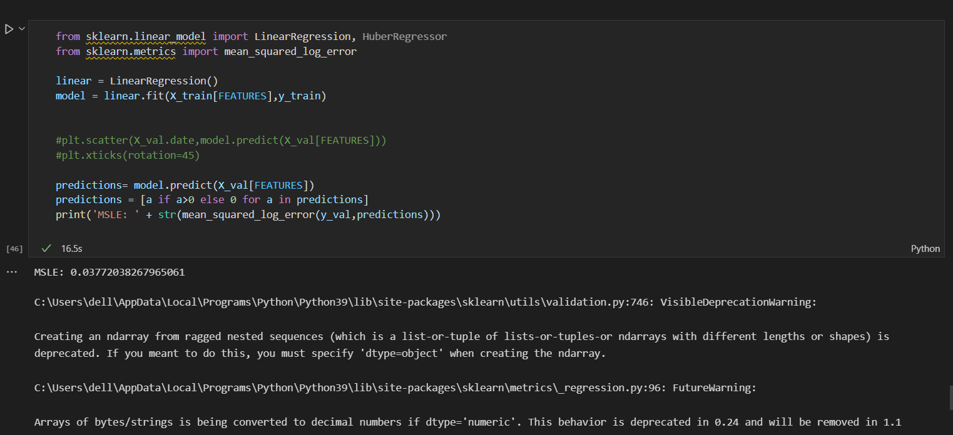
XGboost Regressor
- XGBoost is a useful technique for building supervised regression models. This statement's accuracy can be determined by understanding the (XGBoost) objective function and base learners.
- A regularization term and a loss function are also involved in the objective function. It identifies the difference between actual values and expected values, or how similar the model outputs are to the actual values. Reg:linear is the most famous loss function in XGBoost for regression issues, and reg:logistics is the most used loss function for binary classification.
- The results for root mean Mean squared logarithmic error is 0.03117.

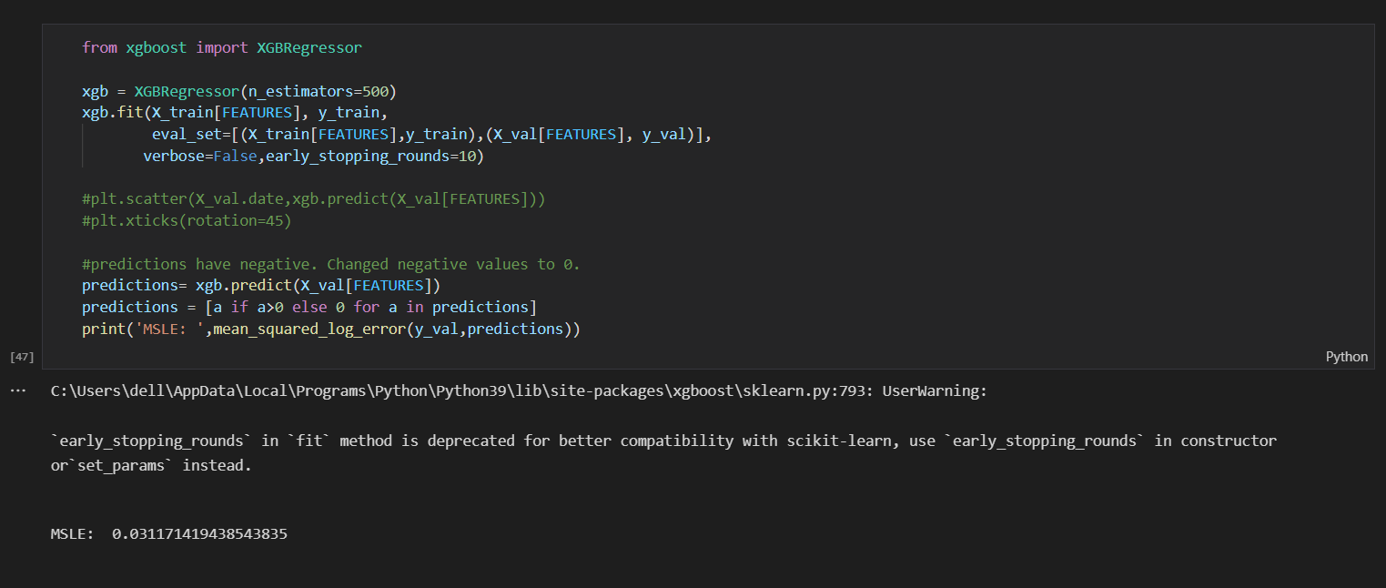

5.CONCLUSION
I take the log of sales based on the discussion here Competition discussion
With all the characteristics we retrieved, we train a basic linear regression, and MSLE performs well (0.03772247906110788).
Then, after training an XGboost regressor, MSLE performs even better (0.031171419438543835).
With this strategy, we may forecast a single model for all the stores, but to add complexity, we can also experiment with many models for various stores, considering variables like promotions and special holidays for each locale.

6.Contributions

Created a Time series Arima model to forecast the sales of a grocery store. To implement the model, made Data Stationary Using PACF ( Partial Auto Correlation Fuller Test), ADF (Augmented Dickey-Fuller Test) and ACF(Auto Correlation fuller Test). Ecuador is an Oil dependent Country, tried to show how the Oil price impacts the sales of a Grocery Store in various Departments. Implemented XGboost Regressor which had a better Value of 0.03117.

7.References
Paper-1
http://rstudio-pubs-static.s3.amazonaws.com/338464_40e4a4ad5b7448feb0c894bb5a300b50.html
Paper-2
https://www.kaggle.com/prashant111/arima-model-for-time-series-forecasting
Paper-3
https://www.sciencedirect.com/science/article/pii/S2667096822000027
Paper-4
https://towardsdatascience.com/sales-forecasting-from-time-series-to-deep-learning-5d115514bfac

